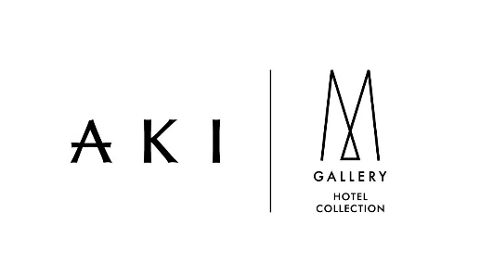

Out and About Travel Guide in Hong Kong
AKI Hong Kong – MGallery is an elegant and stylish new gem, hidden in the heart of the vibrant and historic Wan Chai district close to Hong Kong Convention and Exhibition Centre and it is just an 3-minute walk from MTR station. The lively Causeway Bay shopping district is also just a short stroll away. 173 contemporary Asian guestrooms are thoughtfully designed for smart living in a stylish minimalist aesthetic. Lofty ceilings, natural wood tones, and artful mood lighting, contribute to the calming décor. The hotel features the first Japanese-style tatami rooms in Hong Kong with stunning 270-degree panoramas of the Hong Kong cityscape. All rooms with king-size bed, 50” Smart TV and the US renowned amenities MALIN+GOETZ. Japanese-inspired all-day-dining restaurant TANGARAM, Uncle Ming’s Whiskey Bar, the co-work style Lobby Lounge and 24-hr gymnasium are there provide a full-service experience.
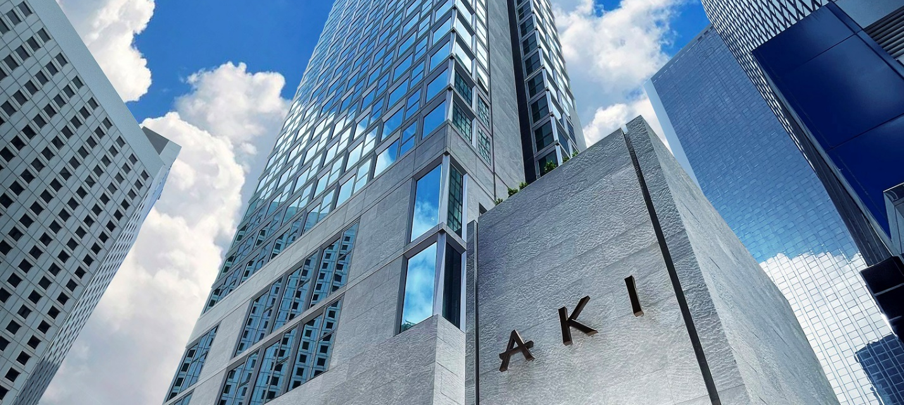
Getting around Hong Kong from AKI
- Hotel is located in between of two metro stations. 3-min walk to Exhibition Centre MTR station and 5-min walk to Wan Chai MTR station. MTR is the most extensive and convenient transportation network throughout Hong Kong.
- Star Ferry Terminal is nearby the hotel with 10-min walk. Stay Ferry can take you across the stunning Victoria Harbour and reach Tsim Sha Tsui shopping area.
- Historical and exceptional tram (ding-ding) has been running across Hong Kong Island for more than 100 years. Tram stops are along the main street (Hennessy Road) outside hotel.
Where to fill your palate
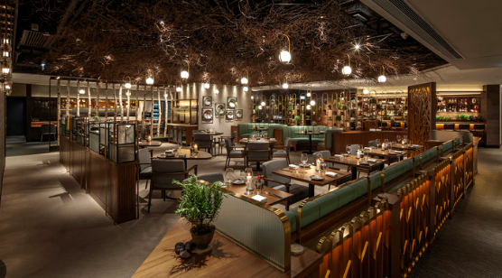 | Roganic  Roganic is a Michelin-starred and green-starred restaurant, which recognizes restaurants that are leaders in the field of sustainability. The restaurant offers a tasting menu of modern European dishes that are made with seasonal ingredients sourced from local farms, house-grown herbs and sustainable ingredients.  Direction: 9-min walk from AKI
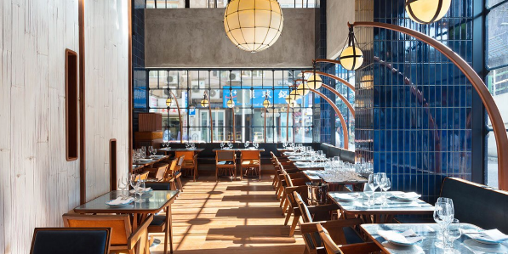 | Osteria Marzia  Osteria Marzia has its Italian menu recently been converted to feature exclusively seafood which is complemented with fresh pasta, grilled meats, and seasonal vegetables. The spacious setting is unabashedly refined, yet relaxed at the same time, like a dinner party at a monied Italian villa. Anticipate warm, knowledgable and attentive staff with service so immaculate that, at times, it feels invisible in the best way possible.  Direction: 2-min walk from AKI
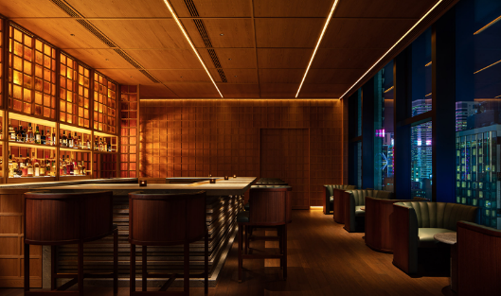 | Uncle Ming’s Whisky Bar  Uncle Ming’s Whisky Bar is a sky-high hotspot for whisky lovers, located at 25/F of AKI Hong Kong - MGallery. With more than 80 international whiskies, including rare single malts, Uncle Ming’s is truly a magnet for lovers of the amber nectar. But everyone will adore this dramatic city view with its indulgent menu of both classic and inventive cocktails and light bites. And the views are simply breath-taking.  Direction: 25/F at AKI Hong Kong -MGallery
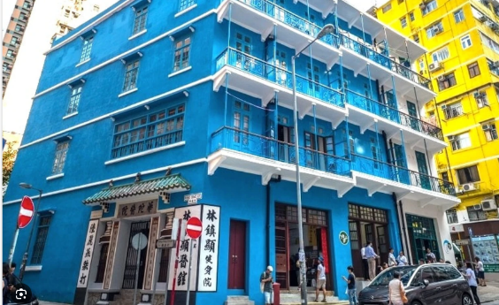 | Blue House  The Blue House is a four-storey tenement building located in Wan Chai. It is one of the few remaining examples of traditional Chinese shophouses in the city. The building was built in 1922 and is named after the blue color of its exterior walls. It is a Grade I historic structure, which denotes that it has unique architectural and historical significance. The Blue House is a popular tourist destination and is also home to a number of art galleries and cultural organizations. It is a great place to learn about the history and culture of Hong Kong.

And so the adventure begins
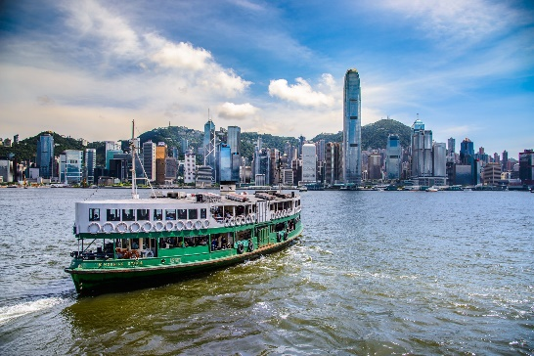 | Star Ferry Pier  Situated at the heart of Victoria Harbour, Star Ferry Pier serves as both a bustling transportation hub and a historic landmark. It links Central on Hong Kong Island to Tsim Sha Tsui in Kowloon, offering a convenient and iconic ferry service that has been in operation for more than a hundred years. Besides its practicality, the Star Ferry Pier is also an astounding photography spot, providing breathtaking panoramic views of Hong Kong’s vibrant cityscape and picturesque harbor.
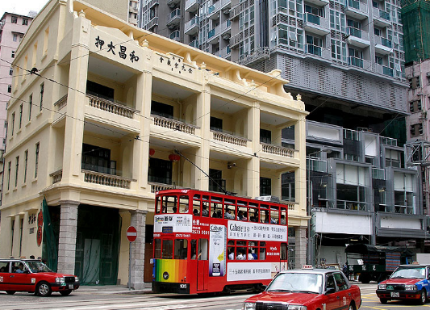 | Pawn Shop  The historical Woo Cheong Pawn Shop has been in operation since 1888. Constructed as a traditional tong lau shophouse—an architectural style widely embraced in Hong Kong from the late nineteenth to mid-twentieth centuries. Back in the day, pawn shops were a popular way for people to get loans. The pawnshop is now closed, but it has been restored to its former glory and is now a cult bar and restaurant.
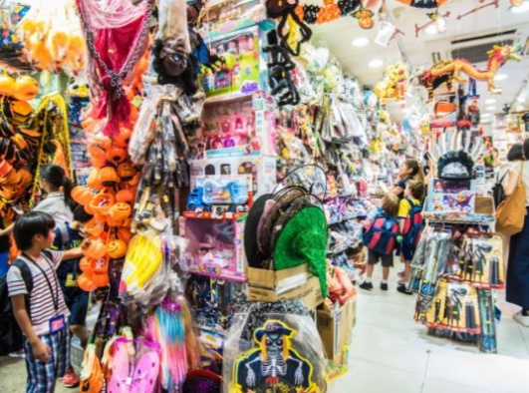 | Tai Yuen Street (Toy Street)  Tai Yuen Street, also known as Toy Street, is a lively and colorful street that is always bustling with activity. It is home to a wide variety of toy shops, selling everything from traditional Chinese toys to imported action figures and dolls. You can find rare and vintage toys here. It is a great place to spend an afternoon browsing the shops and finding unique gifts for friends and family.

For more information, please contact our Concierge or Reception.

